
FYP Final Report Template
TITLE OF THE PROJECT

Final Year Project Report by

Names
(Reg no.)

In Partial Fulfillment
Of the Requirements for the degree
Bachelors of Science in Computer Science (BSCS)

Iqra University H-9 Campus
Islamabad, Pakistan (2025)
FINAL APPROVAL

It is certified that the work printed in this report entitled “ABC” by XYZ, registration No.123 fulfill the requirements for award of degree of BS Computer Science from Department of Computing and Technology, Iqra University H-9 Campus, Islamabad, Pakistan

Viva Voce Committee

Supervisor

Internal Examiner-1:

Internal Examiner-2:

External Examiner:

DEDICATION

DECLARATION OF ORIGINALITY

I, names, registration No.123 student of BS Computer Science, hereby declare that the work presented in the thesis entitled “ABC” in partial fulfillment of BS degree in Computer Science from Iqra University, Islamabad, is my own work and has not been published or submitted as report research work or thesis in any form in any other university or institute in Pakistan or aboard.

Student 1 Name with Signature (Reg. Number)

Student 1 Name with Signature (Reg. Number)

Dated: --------------------------------------------

ACKNOWLEDGEMENT

I have no words to express our deepest gratitude to Allah Almighty for all of his countless blessings. I owe our deepest respect to HIS most noble messenger Hazrat Muhammad (P.B.U.H), who is forever, a torch of guidance and knowledge for all humanity. By virtue of his blessings today we are able to carry out our research work and present it.
The Almighty Allah has blessed me through the people who have contributed to the completion of this project. The first person who worth mentioning is my supervisor Dr.----------who guided me and supported me during our whole development / research work. I specially mention my co-supervisor( if any) Dr. --------for his precious time, which he has given to me. Without his help it was impossible to complete this hard task. He is an inspiring personality for me in all fields specially education. Under his supervision from the preliminary to the concluding level enabled me to develop an understanding of the field. Moreover, I would like to express our sincere thanks to all the faculty members of Department of Computing and Technology, IU Islamabad.
I also hereby extend my thanks to other lab fellows who made this project much easier for me with their guidance and suggestions. Of course, any my acknowledgment would never be completed without expressing gratitude to my parents. I owe everything to them and words are never enough express our attribution to my parents. My achievements in life would never complete without their prayers and support.
May Allah bless all these people

TABLE OF CONTENT (SAMPLE)
ABSTRACT xii
Chapter 1 1
INTRODUCTION 1
Chapter 2 2
PROBLEM DEFINITION 2
Chapter 3 3
LITERATURE REVIEW 3
Chapter 4 5
SOFTWARE REQUIREMENTS SPECIFICATION (SRS) 5
4.1 Introduction 5
4.1.1 Document Purpose 5
4.1.2 Product Scope 5
4.1.3 Definitions, Acronyms, and Abbreviations 5
4.1.4 References 6
4.1.5 Document Overview 6
4.2 Overall Description 6
4.2.1 Product Perspective 6
4.2.2 Product Functions 6
4.2.3 Product Constraints 6
4.2.4 User Characteristics 7
4.2.5 Assumptions and Dependencies 7
4.2.6 Apportioning of Requirements 7
4.3 Specific Requirements 7
4.3.1 External Interfaces 7
4.3.2 Functional Requirements 8
4.3.3 Quality of Service Requirements (Non-Functional Requirements) 8
4.3.4 Compliance 8
4.3.5 Design and Implementation Constraints 8
4.4 Verification 9
4.5 Appendixes 9
Chapter 5 10
Software Design Specification 10
5.1 Design Methodology and Software Process Model 10
5.2 System Overview 10
5.2.1 Architectural Design 10
To view example of box and line diagram and architecture styles, see Appendix A.5.4 Design Models 10
5.5 Data Design 12
5.5.1 Data Dictionary 12
5.6 User Interface Design 12
5.6.1 Screen Images 12
5.6.2 Screen Objects and Actions 12
Chapter 6 13
IMPLEMENTATION AND TESTING 13
Chapter 7 14
RESULTS AND DISCUSSION 14
Chapter 8 15
CONCLUSION AND FUTURE WORK 15
Chapter 9 16
REFERENCES 16
Appendix A 17
Box-and-line diagram 17
Appendix B 19
Design Models 19
Activity Diagram 19
Activity Diagram Syntax 20
Class Diagram 21
Class Diagram Syntax 22
Sequence Diagram 23
Sequence diagram Syntax 24
Behavioral State Machine Diagram 26
Behavioral State Machine Diagram Syntax 26
Guidelines for Drawing DFDs 28
Leveling Example 29
Balancing Example 30
Appendix C 32
Section 1 - Adding Captions and generating Lists of Figures Etc 32
CHAPTER-WISE CHECKLIST 33

LIST OF TABLES( SAMPLE)
Table 1: Comparative Analysis And Gap Analysis 3
Table 2: Gap Analysis for Development-Based Project ( Dummy) 3
Table 3: B- 1 Activity Diagram Syntax 20
Table 4: B- 2 Class Diagram Syntax 22

LIST OF FIGURES( SAMPLE)

Figure 1: Box-and-line diagram 17
Figure 2: Architecture Pattern 18
Figure 3: Activity Diagram 19
Figure 4:Class Diagram 22
Figure 5:Data Flow Diagram 28
Figure 6: Example 28
Figure 7: Example 29
Figure 8: Example 29
Figure 9: Balancing Example 30
Figure 10: Order System DFD Example 30

ABSTRACT

Include a brief summary of the problem statement, challenges, proposed solution, approaches, scope, and comparison with existing systems/evaluation methods, conclusion and future directions. Recommend length is 1 page maximum. Abstract must be self- explanatory and should not include any references or short hand notations in the abstract.

Chapter 1

INTRODUCTION
Introduction is mostly written for non-specialists so that they can get an overview of the project without technical details. It should provide a brief overview of the project aims and structure of the solution. It should also specify what unmet need or problem the FYP caters for and who needs it.
At the end of chapter, provide a summary of the report organization, chapter outlining what has been covered in this chapter and explain what comes in the following chapters.

Chapter 2

PROBLEM DEFINITION

The purpose of this chapter is to clearly define and frame the problem your project aims to solve. It should translate the general idea discussed in earlier chapters into a specific, well-scoped, and technically understandable problem. The reader must understand what exactly the issue is, why it exists, and what its impact is if not solved.

Chapter 3

LITERATURE REVIEW

Provide an overview to the projects background knowledge without too much in detail (stick to the scope of the project). The background can refer to previous work referenced from journals, articles, newspapers, or any academic literature providing evidence that the proposed problem is significant and real problem worth solving.
If available, provide closely related work done within the project scope and the challenges or defects identified which can be considered as part of the new solution.
Describe why you worked on this project in light of the literature review?

Table 1: Comparative Analysis And Gap Analysis
Applications | Purpose | Application Area | Link / Reference | Strengths | Weaknesses
App A | Basic solution but lacks customization | Mobile / Web | https://appA.com | User-friendly, widely adopted | Limited customization
App B | Missing advanced feature support | Industry | https://appB.com | Secure, stable | Expensive, closed-source

Table 2: Gap Analysis for Development-Based Project ( Dummy)
Area | Current State (What Exists) | Identified Gap / Limitation | Proposed Solution (Your App Contribution)
User Needs | Users rely on generic apps with limited customization. | Lack of personalization and user-centric features. | Develop an app with adaptive, user-focused features based on real-time preferences.
Functionality | Existing apps provide only core/basic features. | Advanced integrations (e.g., AI, analytics, offline support) are missing. | Introduce advanced modules such as AI-based recommendations, offline mode, and data visualization.
Usability (UI/UX) | Interfaces are often cluttered and not intuitive. | Poor user experience reduces adoption and engagement. | Implement a clean, modern, responsive design with user-friendly navigation.
Performance & Scalability | Current solutions struggle with large user bases or heavy data. | Low scalability and slow performance under load. | Build a scalable architecture using cloud backend and optimized data handling.
Security & Privacy | Limited or outdated security protocols in some apps. | Risk of data breaches and lack of trust among users. | Incorporate strong encryption, role-based access, and GDPR-compliant privacy controls.
Cost / Accessibility | Many existing solutions are expensive or platform-specific. | Small businesses or ordinary users can’t afford or access them. | Develop a cost-effective, cross-platform app accessible on both Android & iOS.

From the reviewed literature and applications, it is evident that while significant progress has been made, existing approaches either focus heavily on theoretical models with limited real-world implementation or provide industrial solutions lacking adaptability and cost-effectiveness. Therefore, there exists a clear research gap in integrating academic research with practical applications to achieve a more balanced and efficient solution, which this project aims to address.
All sources must be properly cited within the text, with a bibliography presented in alphabetical order following the required format.

Chapter 4

SOFTWARE REQUIREMENTS SPECIFICATION (SRS)

This chapter details the software requirements for the project, adhering to the IEEE 830 standard for Software Requirements Specifications. It provides a comprehensive overview of the system's intended purpose, functionalities, and constraints.

4.1 Introduction
This section provides an overview of the entire Software Requirements Specification (SRS) document, outlining its purpose, scope, and the conventions used within it.

4.1.1 Document Purpose
This document specifies the software requirements for [Project Name]. Its primary purpose is to serve as a comprehensive guide for stakeholders, including developers, testers, project managers, and clients, ensuring a shared understanding of the system's functionalities and constraints. It aims to minimize ambiguities and facilitate effective communication throughout the development lifecycle.

4.1.2 Product Scope
This SRS describes the requirements for [Product Name/System Name], version [Version Number]. The system is designed to [briefly explain what the product will do, its main purpose, and key benefits]. This document focuses on the software components and their interactions, defining the boundaries of the system and what it is intended to achieve. It does not cover [mention what is explicitly out of scope, e.g., hardware specifications, operational procedures not directly related to software].

4.1.3 Definitions, Acronyms, and Abbreviations
This subsection provides definitions of all terms, acronyms, and abbreviations used throughout this document to ensure clarity and consistency. (e.g., SRS, SDD, GUI, API, etc.)

4.1.4 References
This section lists all documents and web resources referenced in this SRS. This includes relevant standards, existing system documentation, and any other materials that provide context or supplementary information.

- [2] jam01/SRS-Template, GitHub repository. Available at:
https://github.com/jam01/SRS-Template

4.1.5 Document Overview
This document is organized into several sections. Following this introduction, Section 3.2 provides a general description of the product, including its perspective, functions, user characteristics, constraints, and assumptions. Section 3.3 details the specific functional and non-functional requirements of the system. Finally, Section 3.4 outlines the verification methods, and Section 3.5 includes any appendices.

4.2 Overall Description
This section describes the general factors that affect the product and its requirements, providing a background for the detailed requirements defined in Section 3.3.

4.2.1 Product Perspective
[Product Name] is a [type of product, e.g., new, standalone application, a component of a larger system, a replacement for an existing system]. It interacts with [mention other systems, hardware, or software components it integrates with]. A high-level diagram illustrating the product's position within the larger system context and its interfaces with external entities is provided in Figure 3.1.

4.2.2 Product Functions
This subsection summarizes the major functions that the product will perform. These functions are elaborated in detail in Section 3.3.2. (e.g., User authentication, Data management, Reporting, etc.)

4.2.3 Product Constraints
This subsection outlines any limitations or restrictions that will influence the design and implementation of the product. These may include regulatory requirements, hardware limitations, operating environment, or specific technologies to be used.

4.2.4 User Characteristics
This section identifies the various user classes who will interact with the product. For each user class, relevant characteristics such as technical expertise, frequency of use, and privilege levels are described. (e.g., Administrator, End-User, Guest, etc.)

4.2.5 Assumptions and Dependencies
This subsection lists any factors that are assumed to be true during the development process and any external dependencies that could impact the project if they change or are not met. (e.g., availability of third-party APIs, specific operating system versions, etc.)

4.2.6 Apportioning of Requirements
This section describes how the software requirements are allocated to different software elements or subsystems, and identifies any requirements that may be deferred to future releases.

4.3 Specific Requirements
This section specifies all software requirements in detail, ensuring they are sufficient for design and testing. Each requirement should be uniquely identifiable, verifiable, and clearly stated.

4.3.1 External Interfaces
This subsection defines all inputs and outputs of the software system, including user, hardware, software, and communication interfaces.

4.3.1.1 User Interfaces
Describes the logical characteristics of the user interface, including screen layouts, navigation, standard controls, and any GUI standards to be followed.

4.3.1.2 Hardware Interfaces
Describes the interfaces between the software and hardware components, including configuration data, memory maps, and device control.

4.3.1.2 Software Interfaces
Describes the interfaces with other software components, such as operating systems, databases, and external applications, including data exchange formats and protocols.

4.3.1.3 Communications Interfaces
Describes communication protocols, message formats, and data rates for network interfaces.

4.3.2 Functional Requirements
This section details the services the system must provide, how it should react to inputs, and its behavior in specific situations. Functional requirements can be expressed as use cases or user stories.

4.3.3 Quality of Service Requirements (Non-Functional Requirements)
This section specifies the non-functional requirements, which are constraints on the system's operations and attributes. These include performance, security, reliability, availability, usability, maintainability, portability, scalability, interoperability, and compliance.

4.3.3.1 Performance
Specifies requirements related to speed, response time, throughput, and resource utilization.

4.3.3.2 Security
Specifies requirements for protecting the system from unauthorized access, use, disclosure, disruption, modification, or destruction.

4.3.3.3 Reliability
Specifies requirements for the system's ability to perform its functions under stated conditions for a specified period of time.

4.3.3.4 Availability
Specifies requirements for the system's operational uptime and accessibility.

4.3.4 Compliance
Specifies requirements for adherence to industry standards, regulations, and legal obligations.

4.3.5 Design and Implementation Constraints
Specifies any constraints on the design and implementation, such as required programming languages, development tools, or architectural patterns.

4.4 Verification
This section describes the methods and criteria used to verify that the software product satisfies its requirements. This includes testing strategies, inspection, and demonstration.

4.5 Appendixes
This section includes any supplementary information that supports the SRS but is not essential to its main body, such as sample data, detailed algorithms, or diagrams.

Chapter 5

Software Design Specification

The purpose of this chapter is to clearly define and frame the problem your project aims to solve. It should translate the general idea discussed in earlier chapters into a specific, well-scoped, and technically understandable problem. The reader must understand what exactly the issue is, why it exists, and what its impact is if not solved.

5.1 Design Methodology and Software Process Model
Explain and justify the choice of design methodology being followed. (OOP or Procedural). Also explain which process model you are following and why.

5.2 System Overview
Give a general description of the functionality, context, and design of your project.
Provide any background information if necessary.

5.2.1 Architectural Design
Develop a modular program structure and explain the relationships between the modules to achieve the complete functionality of the system. This is a high-level overview of how the system’s modules collaborate with each other in order to achieve the desired functionality.
Don’t go into too much detail about the individual subsystems. The main purpose is to gain a general understanding of how and why the system was decomposed, and how the individual parts work together.
Provide a diagram showing the major subsystems and their connections.
- In initial design stage create Box and Line Diagram for simpler representation of the systems
- After finalizing architecture style/pattern diagram (MVC, Client-Server, Layered, Multi-tiered) create a detailed mapping modules/components to each part of the architecture

To view example of box and line diagram and architecture styles, see Appendix A.

5.4 Design Models
Create design models as are applicable to your system. Provide detailed descriptions with each of the models that you add. Also ensure visibility of all diagrams.
Note: Follow version 2.5 for UML diagrams

Design Models for Object Oriented Development Approach
The applicable models for the project using object-oriented development approach may include:
- Class Diagram
- Sequence Diagram
- State Transition Diagram (for the projects which include event handling and backend processes)
- Activity Diagram
- Data flow diagrams

Design Models for Procedural Approach

The applicable models for the project using procedural approach may include:
- Activity Diagram
- Data Flow Diagram (data flow diagram should be extended to 2-3 levels. It should clearly list all processes, their sources/sinks and data stores.)
- State Transition Diagram (for the projects which include event handling and backend processes)

To view examples of all above models, see Appendix B

5.5 Data Design
Explain how the information domain of your system is transformed into data structures. Describe how the major data or system entities are stored, processed, and organized.

List any databases or data storage items in the form of data representation diagram (ERD, XML schema, SON schema etc.) with description.

5.5.1 Data Dictionary
Alphabetically list the system entities or major data along with their types and descriptions. If you provided a functional description, list all the functions and function parameters. If you provided an OO description, list the objects and its attributes, methods and method parameters.

5.6 User Interface Design
Describe the functionality of the system from the user’s perspective. Explain how the user will be able to use your system to complete all the expected features and the feedback information that will be displayed for the user.

Screen Images
Display screenshots showing the interface from the user’s perspective. These can be hand-drawn, or you can use an automated drawing tool. Just make them as accurate as possible. (Graph paper works well.)

5.6.2 Screen Objects and Actions
A discussion of screen objects and actions associated with those objects

Chapter 6

IMPLEMENTATION AND TESTING

Explain the methods, tools and techniques used to develop the software. What kind of software and testing methodologies implemented. Explain core functionalities in narrative format. Controlled libraries, templates, code walkthroughs,
Explain how the proposed software has been evaluated and compared at runtime with the original specifications. The Accuracy, Performance and Scalability of the proposed software must be critically analyzed and should solve identified problem statement.

Chapter 7

RESULTS AND DISCUSSION

A comprehensive evaluation of the solution is presented with supporting figures and graphics.
System testing is performed through a strong testing strategy and the test cases cover all the use cases.

Chapter 8

CONCLUSION AND FUTURE WORK

Include a brief summary of how the proposed solution is going to/has addressed the problem statement specified in the introduction section. Provide an overview of what kind of evaluations were undertaken in order to prove that the solution really solves the problem with evidence on results findings.
Provide an overview of the recommendations and Include a future directions which is required as part of the future work.

Chapter 9

REFERENCES

A comprehensive list of references is cited using a standard form.

Appendix A

Box-and-line diagram

Box-and-line diagrams are often used to describe the business concepts and processes during the analysis phase of the software development lifecycle. These diagrams come with descriptions of components and connectors, as well as other descriptions that provide common inherent interpretations.
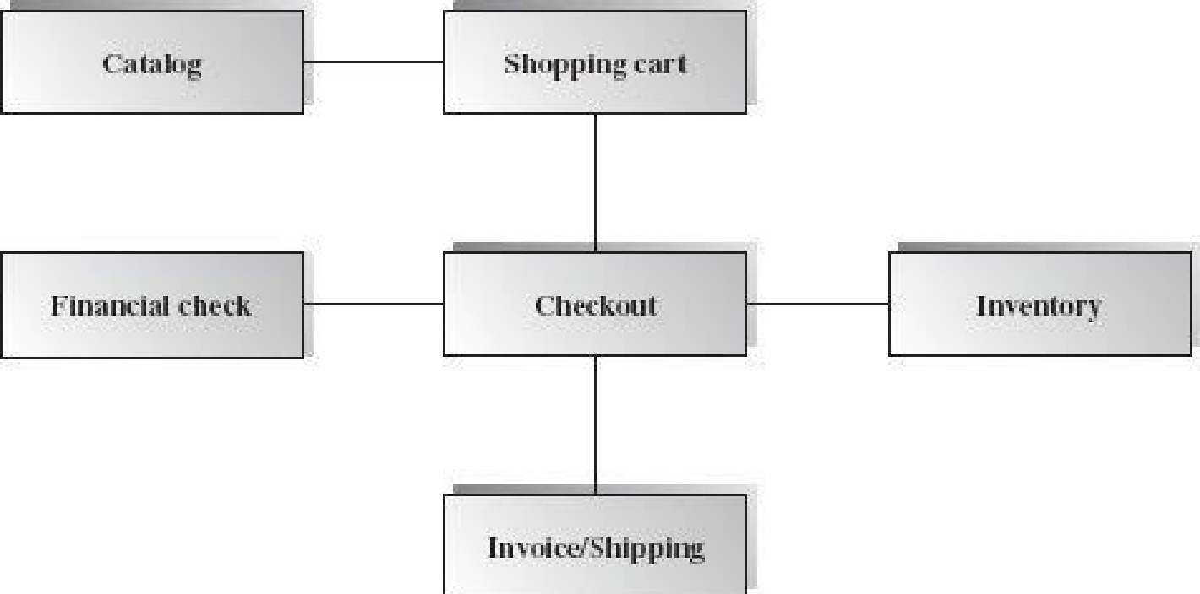
Example:
Figure 1: Box-and-line diagram
Figure A- SEQ Figure \* ARABIC 1 Box-and-Line Diagram for an Online Shopping Business
Lines in the box-and-line diagrams indicate the relationship among components
- The semantic of lines may refer dependency, control flow, data flow, etc
- Lines may be associated with arrows to indicate the process direction and sequence.
- A box-and-line diagram can be used as a business concept diagram describing its application domain and process concepts

Example of Architecture Pattern:
The figure A-2 shows an example of the logical package organization of the layered architecture. The top level deals with user interface, the next level is for utilities, and the one below utility provides core services. Each layer gets support from its lower adjacent layer by an interface implementation and from the related classes in the same layer.
A simple software system may consist of two layers: an interaction layer and a processing layer:
- The interaction layer provides user interfaces to clients, takes requests, validates and forwards requests to the processing layer for processing, and responds to clients.
- The processing layer receives the forwarded requests and performs the business logic process, accesses the database, returns the results to its upper layer, and lets the upper layer respond to clients since the upper layer has the GUI interface responsibility.
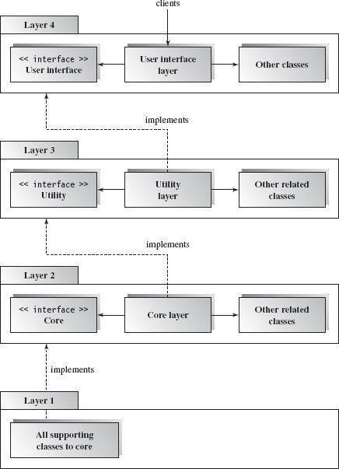
Figure A- SEQ Figure \* ARABIC 2 Component-based Layered Architecture
Figure 2: Architecture Pattern

Note: The Architecture pattern shall be selected according to the targeted system’s requirements and quality attributes. Above example is provided to demonstrate that how the system architecture is required to be presented.

Appendix B

Design Models

Activity Diagram
The following activity diagram is for an appointment system presenting a “make an appointment” process in which all diagram’s elements are presented. Furthermore, Table B-1 presents the details of the syntax of an activity diagram.
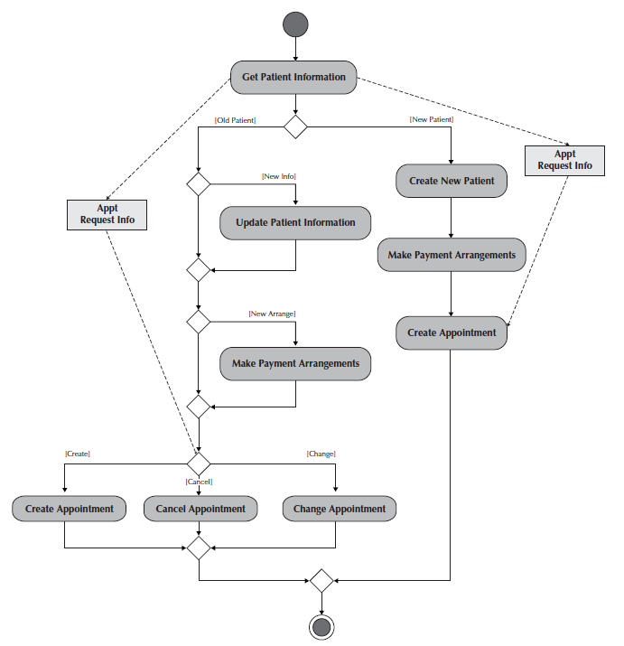
Example:
Activity Diagram SEQ Activity_Diagram \* ARABIC 1: Activity Diagram for Make an Appointment Process
Figure B-1 Activity Diagram for Make an Appointment Process
Figure 3: Activity Diagram

Activity Diagram Syntax
Table 3: B- 1 Activity Diagram Syntax
Term and definition | Symbol
An action:  - Is a simple, non-decomposable piece of behavior.  - Is labeled by its name. | 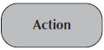
An activity:  - Is used to represent a set of actions.  - Is labeled by its name. | 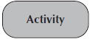
An object node:  - Is used to represent an object that is connected to a set of object flows.  - Is labeled by its class name. | 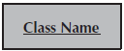
A control flow:
- Shows the sequence of execution.
An object flow:
- Shows the flow of an object from one activity (or action) to another activity (or action).
An initial node:  - Portrays the beginning of a set of actions or activities. | 
A final-activity node:  - Is used to stop all control flows and object flows in an activity (or action). | 
A final-flow node:  - Is used to stop a specific control flow or object flow. | 
A decision node:  - Is used to represent a test condition to ensure that the control flow or object flow only goes down one path.  - Is labeled with the decision criteria to continue down the specific path. | 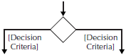
A merge node:  - Is used to bring back together different decision paths that were created using a decision node. | 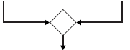
A fork node:  - Is used to split behavior into a set of parallel or concurrent flows of activities (or action) | 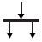
A join node:  - Is used to bring back together a set of parallel or concurrent flows of activities (or action) | 
A swimlane:  - Is used to break up an activity diagram into rows and columns to assign the individual activities (or actions) to the individuals or objects that are responsible for executing the activity (or action)  - Is labeled with the name of the individual or object responsible | 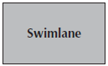

Class Diagram
Following class diagram is of an appointment system in which all class diagram elements are presented. Table B-2 presents the syntax of the class diagram as a guideline.
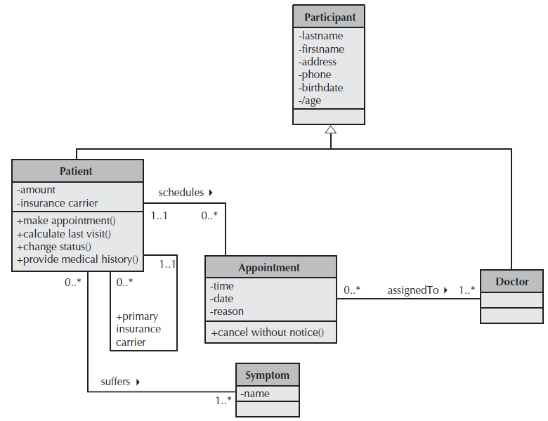
Example
Figure 4:Class Diagram
Class Diagram SEQ Class_Diagram \* ARABIC 1: Class Diagram for an Appointment System

Class Diagram Syntax
Table 4: B- 2 Class Diagram Syntax
Term and definition | Symbol
A class:  - Has a name typed in bold and centered in its top compartment.  - Has a list of attributes in its middle compartment.  - Represents a kind of person, place, or thing about which the system will need to capture and store information.  - Has a list of operations in its bottom compartment.  - Does not explicitly show operations that are available to all classes. | 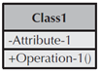
An attribute:  - Represents properties that describe the state of an object.  - Can be derived from other attributes, shown by placing a slash before the attribute’s name. | attribute name  /derived attribute name
An operation:  - Represents the actions or functions that a class can perform.  - Can be classified as a constructor, query, or update operation.  - Includes parentheses that may contain parameters or information needed to perform the operation. | 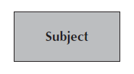  operation name ()
An association:  - Represents a relationship between multiple classes or a class and itself.  - Is labeled using a verb phrase or a role name, whichever better represents the relationship.  - Can exist between one or more classes.  - Contains multiplicity symbols, which represent the minimum and maximum times a class instance can be associated with the related class instance. |   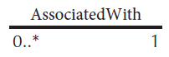
A generalization:  - Represents a-kind-of relationship between multiple classes. | 
An aggregation:  - Represents a logical a-part-of relationship between multiple classes or a class and itself.  - Is a special form of an association. | 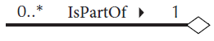
A composition:  - Represents a physical a-part-of relationship between multiple classes or a class and itself  - Is a special form of an association. | 

Sequence Diagram
Following example shows an instance sequence diagram that depicts the objects and messages for the Make Old Patient Appt use case, which describes the process by which an existing patient creates a new appointment or cancels or reschedules an appointment. In further in Table B-3 to the detail of class diagram syntax is provided.
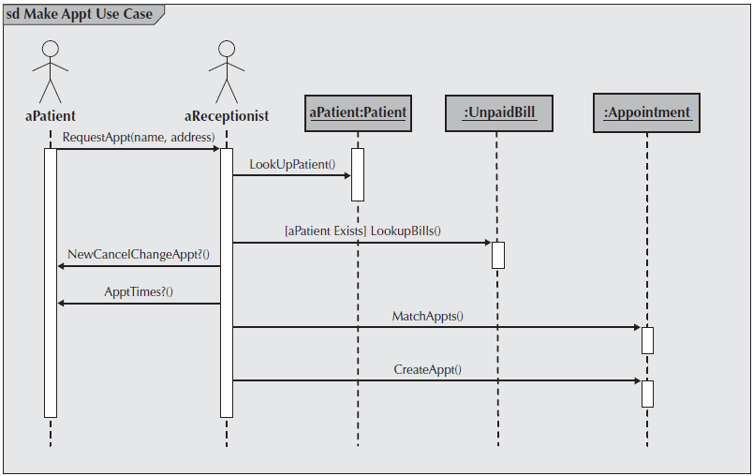
Example
Figure B-3
Sequence Diagram SEQ Sequence_Diagram \* ARABIC 1: Sequence Diagram

Sequence diagram Syntax

Table B-3 Sequence Diagram Syntax
Term and definition | Symbol
An actor:  - Is a person or system that derives benefit from and is external to the system.  - Participates in a sequence by sending and/or receiving messages.  - Is placed across the top of the diagram.  - Is depicted either as a stick figure (default) or, if a nonhuman actor is involved, as a rectangle with <<actor>> in it (alternative). | 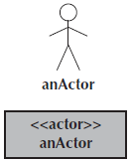
An object:  - Participates in a sequence by sending and/or receiving messages.  - Is placed across the top of the diagram. | 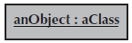
A lifeline:
- Denotes the life of an object during a sequence.
- Contains an X at the point at which the class no longer interacts.
An execution occurrence:
- Is a long narrow rectangle placed atop a lifeline.
- Denotes when an object is sending or receiving messages.
A message:  - Conveys information from one object to another one.  - An operation call is labeled with the message being sent and a solid arrow, whereas a return is labeled with the value being returned and shown as a dashed arrow. | 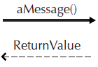
A guard condition:  - Represents a test that must be met for the message to be sent. | 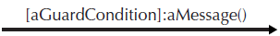
For object destruction:
- An X is placed at the end of an object’s lifeline to show that it is going out of existence.
A frame:  - Indicates the context of the sequence diagram. | 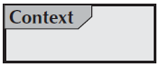

Behavioral State Machine Diagram
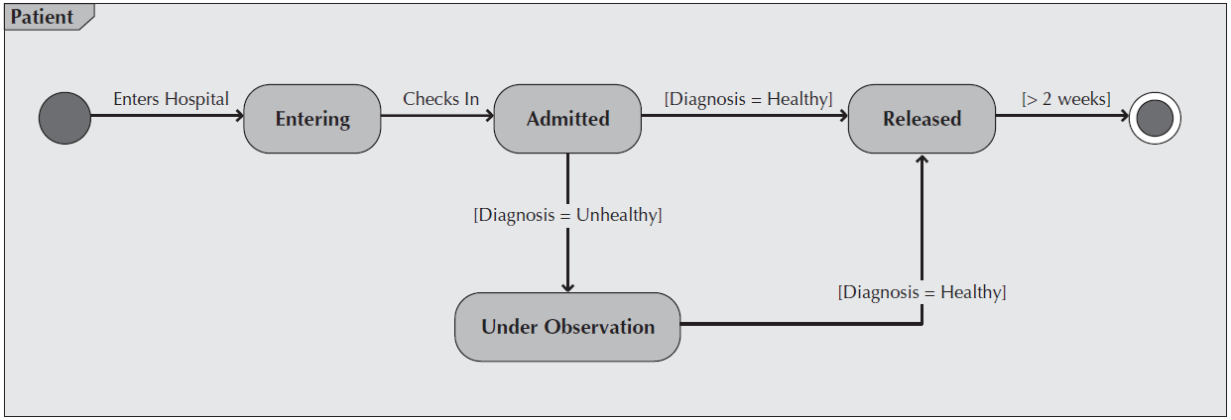
Following example of a behavioral state machine representing the patient class in the context of a hospital environment. From this diagram, we can tell that a patient enters a hospital and is admitted after checking in. If a doctor finds the patient to be healthy, he or she is released and is no longer considered a patient after two weeks elapse. If a patient is found to be unhealthy, he or she remains under observation until the diagnosis changes.

Example
Figure B-4
State Machine Diagram SEQ State_Machine_Diagram \* ARABIC 1: Sample Behavioral State Machine Diagram

Behavioral State Machine Diagram Syntax

Table B-4 Behavioral State Machine Diagram Syntax
Term and definition | Symbol
A state:  - Is shown as a rectangle with rounded corners.  - Has a name that represents the state of an object. | 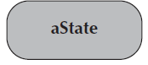
An initial state:
- Is shown as a small, filled-in circle.
- Represents the point at which an object begins to exist.
A final state:  - Is shown as a circle surrounding a small, filled-in circle (bull's-eye).  - Represents the completion of activity. | 
An event:
- Is a noteworthy occurrence that triggers a change in state.
- Can be a designated condition becoming true, the receipt of an explicit signal from one object to another, or the passage of a designated period of time.
- Is used to label a transition.
A transition:
- Indicates that an object in the first state will enter the second state.
- Is triggered by the occurrence of the event labeling the transition.
- Is shown as a solid arrow from one state to another, labeled by the event name.
A frame:  - Indicates the context of the behavioral state machine. | 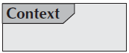

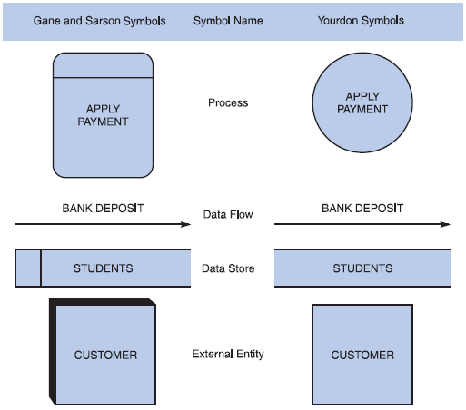
Figure 5:Data Flow Diagram

Data flow diagram symbols, symbol names, and examples
Data Flow Diagrams SEQ Data_Flow_Diagrams \* ARABIC 1: Data flow diagram symbols, symbol names, and examples of the Gane and Sarson and Yourdon symbol sets
Figure B-5.

Guidelines for Drawing DFDs
Step 1: Draw a Context Diagram: The first step in constructing a set of DFDs is to draw a context diagram. A context diagram is a top-level view of an information system that shows the system’s boundaries and scope. Data stores are not shown in the context diagram because they are contained within the system and remain hidden until more detailed diagrams are created.
Example
Data Flow Diagrams SEQ Data_Flow_Diagrams \* ARABIC 2: Context diagram DFD for an order system
Step 2: Draw a Diagram 0 DFD: To show the detail inside the black box, you create DFD diagram 0. Diagram 0 zooms in on the system and shows major internal processes, data flows, and data stores. Diagram 0 also repeats the entities and data flows that appear in the context diagram. When you expand the context diagram into DFD diagram 0, you must retain all the connections that flow into and out of process 0.
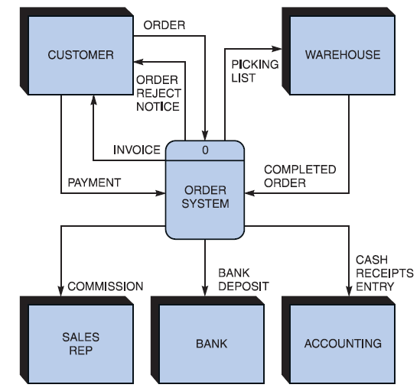

Figure 6: Example

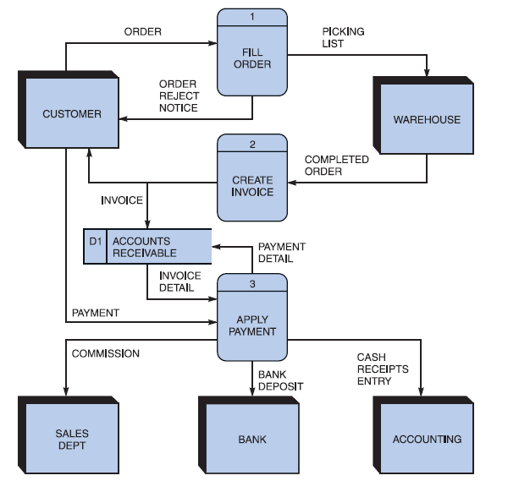
Example
Figure B-7 Diagram 0 DFD for the order system.
Figure 7: Example

Step 3: Draw the Lower-Level Diagrams:
To create lower-level diagrams, you must use leveling and balancing techniques. Leveling is the process of drawing a series of increasingly detailed diagrams, until all functional primitives are identified.

Leveling Example
Figure B-8 Diagram 1 DFD shows details of the FILL ORDER process in the order system.
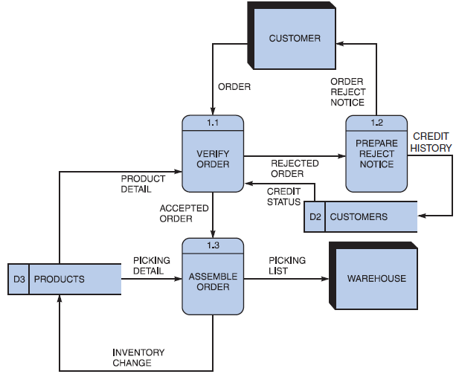
Balancing maintains consistency among a set of DFDs by ensuring that input and output data flows align properly.
Figure 8: Example

Balancing Example
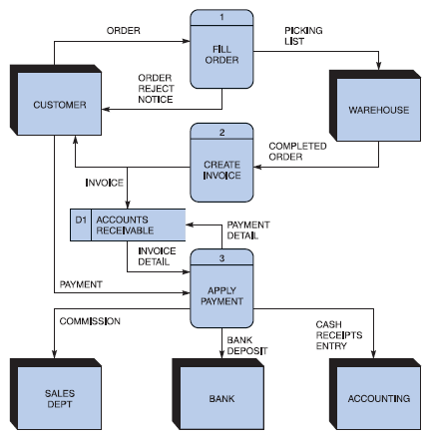
Order System Diagram 0 DFD
Figure 9: Balancing Example

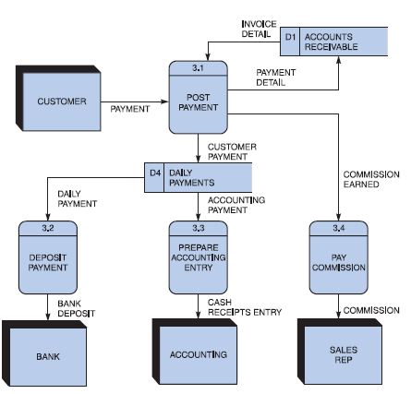
Order System Diagram 3 DFD
Figure 10: Order System DFD Example

The order system diagram 0 is shown at the top of the figure and exploded diagram 3 DFD (for the APPLY PAYMENT process) is shown at the bottom. The two DFDs are balanced, because the child diagram at the bottom has the same input and output flows as the parent process 3 shown at the top.

Appendix C

Section 1 - Adding Captions and generating Lists of Figures Etc
Add, format, or delete captions in Word

CHAPTER-WISE CHECKLIST
Chapter 1: Introduction
☐ Clearly defines project background and context.
☐ Explains the unmet need or problem area.
☐ States the project’s main objectives.
☐ Defines the scope and boundaries of the project.
☐ Mentions the significance and relevance of the project.
☐ Provides a brief overview of report organization.
☐ Uses clear, non-technical language suitable for general readers.

Chapter 2: Problem Definition
☐ Clearly defines the main problem the project solves.
☐ Explains the cause and impact of the problem.
☐ States the motivation and real-world relevance.
☐ Describes how the problem aligns with industry/research needs.
☐ Presents measurable or observable parameters for validation.
Chapter 3: Literature Review
☐ Summarizes existing work (research and development-based).
☐ Includes relevant journals, articles, or applications related to the project.
☐ Identifies limitations, weaknesses, or research gaps.
☐ Provides a comparative analysis (table or descriptive).
☐ Discusses how your project addresses identified gaps.
☐ All sources properly cited (APA/IEEE format).
☐ Ends with a concise summary highlighting key takeaways.
Chapter 4: Software Requirements Specification (SRS)
☐ States the purpose and scope of the document.
☐ Defines system goals and product perspective.
☐ Lists functional and non-functional requirements.
☐ Includes user, hardware, and software interfaces.
☐ Provides constraints, assumptions, and dependencies.
☐ Follows IEEE 830 standard format.
☐ Includes diagrams (e.g., use case, DFD, ERD).
☐ Lists verification criteria or methods.

Chapter 5: Software Design Specification (SDS)
☐ Follows IEEE 1016-2009 standard for software design documentation.
☐ Explains system decomposition (modules, subsystems).
☐ Defines logical, process, development, and physical views.
☐ Provides detailed component design with diagrams.
☐ Defines interfaces, data flow, and data design (ERD, schema).
☐ Describes UI/UX design, navigation flow, and screen layouts.
☐ Includes data dictionary and storage mechanisms.

Chapter 6: Implementation and Testing
☐ Describes implementation process and development environment.
☐ Mentions programming languages, frameworks, and tools used.
☐ Presents screenshots of main modules.
☐ Defines and executes test cases for each module.
☐ Includes functional, integration, and system testing.
☐ Analyzes performance, accuracy, scalability, and security.
☐ Compares actual results with expected outcomes.
Chapter 7: Results and Discussion
☐ Presents results in figures, tables, or charts.
☐ Interprets results and relates them to objectives.
☐ Analyzes system performance and efficiency.
☐ Highlights improvements over existing solutions.
☐ Discusses limitations or challenges faced.
☐ Maintains logical flow from implementation to findings.
Chapter 8: Conclusion and Future Work
☐ Summarizes the entire project and its outcomes.
☐ Restates how objectives and problem statement were achieved.
☐ Highlights contributions and impact of the project.
☐ Mentions limitations of the current version.
☐ Provides realistic suggestions for future enhancements.
☐ Ends with a strong concluding remark.
References
☐ All sources cited consistently (IEEE / APA style).
☐ In-text citations match reference list.
☐ Reference list arranged alphabetically.
☐ Includes books, journals, and web sources used.
☐ Each source has sufficient bibliographic detail (author, title, year, URL/DOI).
Appendices (Optional)
☐ Includes survey questionnaires, datasets, or user manuals.
☐ Contains screenshots, API documentation, or source code snippets.
☐ Supplementary material supports the main text.

